**Lab report no 1**



**Fall 2022**

# Control System Lab

**Submitted By**

**Names Registration No**

# Muhammad Ali 19pwcse1801

Section: **A**

**Date**: 12,10,22

**Submitted to: Dr Muniba Ashfaq**

Department of Computer Systems Engineering

University of Engineering and Technology, Peshawar

**Objectives: -**

* **To learn and get familiar with the basics function using help command.**
* **To practice each command in MATLAB.**

**With help: Description and example of following functions: -**

>> help roots

ROOTS Find polynomial roots.

ROOTS(C) computes the roots of the polynomial whose coefficients

are the elements of the vector C. If C has N+1 components,

the polynomial is C(1)*X^N + ... + C(N)*X + C(N+1).

>> help poly

POLY Convert roots to polynomial.

POLY(A), when A is an N by N matrix, is a row vector with

N+1 elements which are the coefficients of the

characteristic polynomial, DET(lambda*EYE(SIZE(A)) - A) .

POLY(V), when V is a vector, is a vector whose elements are

the coefficients of the polynomial whose roots are the

elements of V . For vectors, ROOTS and POLY are inverse

functions of each other, up to ordering, scaling, and

roundoff error.

>> help polyval

POLYVAL Evaluate polynomial.

Y = POLYVAL(P,X) returns the value of a polynomial P evaluated at X. P

is a vector of length N+1 whose elements are the coefficients of the

polynomial in descending powers.

Y = P(1)*X^N + P(2)*X^(N-1) + ... + P(N)*X + P(N+1)

Example:

Evaluate the polynomial p(x) = 3x^2+2x+1 at x = 5,7, and 9:

p = [3 2 1];

polyval(p,[5 7 9])%

>> help conv

CONV Convolution and polynomial multiplication.

C = CONV(A, B) convolves vectors A and B. The resulting vector is

length MAX([LENGTH(A)+LENGTH(B)-1,LENGTH(A),LENGTH(B)]). If A and B are

vectors of polynomial coefficients, convolving them is equivalent to

multiplying the two polynomials.

>> help tf

TF Construct transfer function or convert to transfer function.

Construction:

SYS = TF(NUM,DEN) creates a continuous-time transfer function SYS with

numerator NUM and denominator DEN. SYS is an object of type TF when

NUM,DEN are numeric arrays, of type GENSS when NUM,DEN depend on tunable

parameters (see REALP and GENMAT), and of type USS when NUM,DEN are

uncertain (requires Robust Control Toolbox).

SYS = TF(NUM,DEN,TS) creates a discrete-time transfer function with

sampling time TS (set TS=-1 if the sampling time is undetermined).

S = TF('s') specifies the transfer function H(s) = s (Laplace variable).

Z = TF('z',TS) specifies H(z) = z with sample time TS.

You can then specify transfer functions directly as expressions in S

or Z,

for example,

s = tf('s'); H = exp(-s)*(s+1)/(s^2+3*s+1)

help pzmap

PZMAP Pole-zero map of dynamic systems.

PZMAP(SYS) computes the poles and (transmission) zeros of the

dynamic system SYS and plots them in the complex plane. The poles

are plotted as x's and the zeros are plotted as o's.

PZMAP(SYS1,SYS2,...) shows the poles and zeros of several systems

SYS1,SYS2,... on a single plot. You can specify distinctive colors

for each model, for example:

pzmap(sys1,'r',sys2,'y',sys3,'g')

[P,Z] = PZMAP(SYS) returns the poles and zeros of the system in two

column vectors P and Z. No plot is drawn on the screen.

>> help impulse

IMPULSE Impulse response of dynamic systems.

IMPULSE(SYS) plots the impulse response of the dynamic system SYS. For systems

with more than one input, independent impulse commands are applied to each

input channel. The time range and number of points are chosen automatically.

For continuous-time systems with direct feedthrough, the infinite pulse at

t=0 is ignored.

IMPULSE(SYS,TFINAL) simulates the impulse response from t=0 to the final time

t=TFINAL (expressed in the time units specified in SYS.TimeUnit). For

discrete-time models with unspecified sampling time, TFINAL is interpreted

as the number of samples.

>> help step

STEP Step response of dynamic systems.

STEP(SYS) plots the step response of the dynamic system SYS. For systems

with more than one input, independent step commands are applied to each

input channel. The time range and number of points are chosen automatically.

STEP(SYS,TFINAL) simulates the step response from t=0 to the final time

t=TFINAL (expressed in the time units specified in SYS.TimeUnit). For

discrete-time models with unspecified sampling time, TFINAL is interpreted

as the number of samples.

>>help series

SERIES Series connection of two input/output models.

M = SERIES(M1,M2,OUTPUTS1,INPUTS2) connects the input/ouput models

M1 and M2 in series. The vectors of indices OUTPUTS1 and INPUTS2

specify which outputs of M1 and which inputs of M2 are connected

together. The resulting model M maps u1 to y2.

>> help parallel

parallel is both a directory and a function.

PARALLEL Parallel connection of two input/output models.

M = PARALLEL(M1,M2,IN1,IN2,OUT1,OUT2) connects the input/output models

M1 and M2 in parallel. The inputs specified by IN1 and IN2 are connected

and the outputs specified by OUT1 and OUT2 are summed. The resulting

model M maps [v1;u;v2] to [z1;y;z2]. The vectors IN1 and IN2 contain

indices into the input vectors of M1 and M2, respectively, and define

the input channels u1 and u2 in the diagram. Similarly, the vectors

OUT1 and OUT2 contain indexes into the outputs of M1 and M2.

**Practical examples and Results: -**

clc

clear all

close all

%initial values for d/f function

p=[1 2 5];

den = [2 4 1];

nom = [3 2 5];

%finding roots

r=roots(p);

%finding poly

p=poly(r);

%finding ployval

p_value = polyval(p,r);

%finding conv

convalution = conv(r,p);

%finding transfer function

transfer_fuc = tf(nom,den);

%finding pzmap

pzmap(transfer_fuc);

%finding impulse

[h,t]= impz(convalution);

%finding step

step(transfer_fuc);

**Resulted values: -**

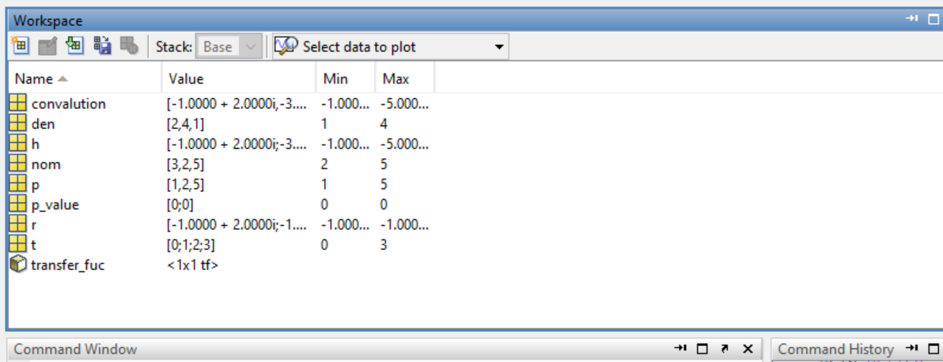

**Step:**

